Quality of employment - Labour market - Eurostat

Dimensions of quality of employment:

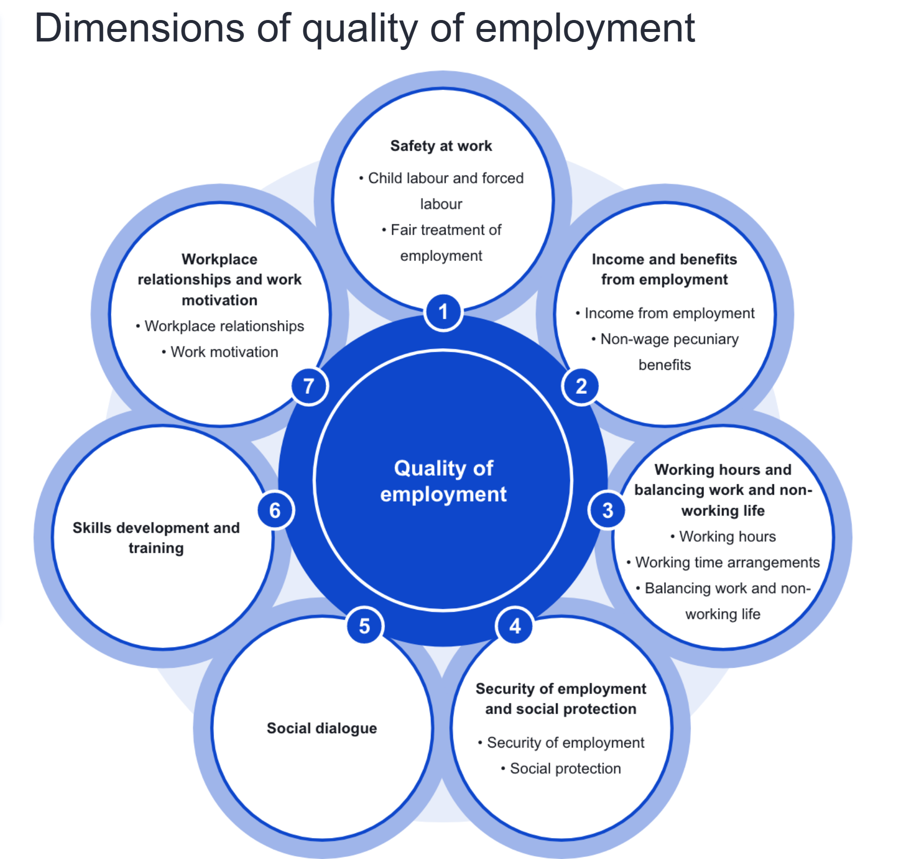

The earning & benefit comparison :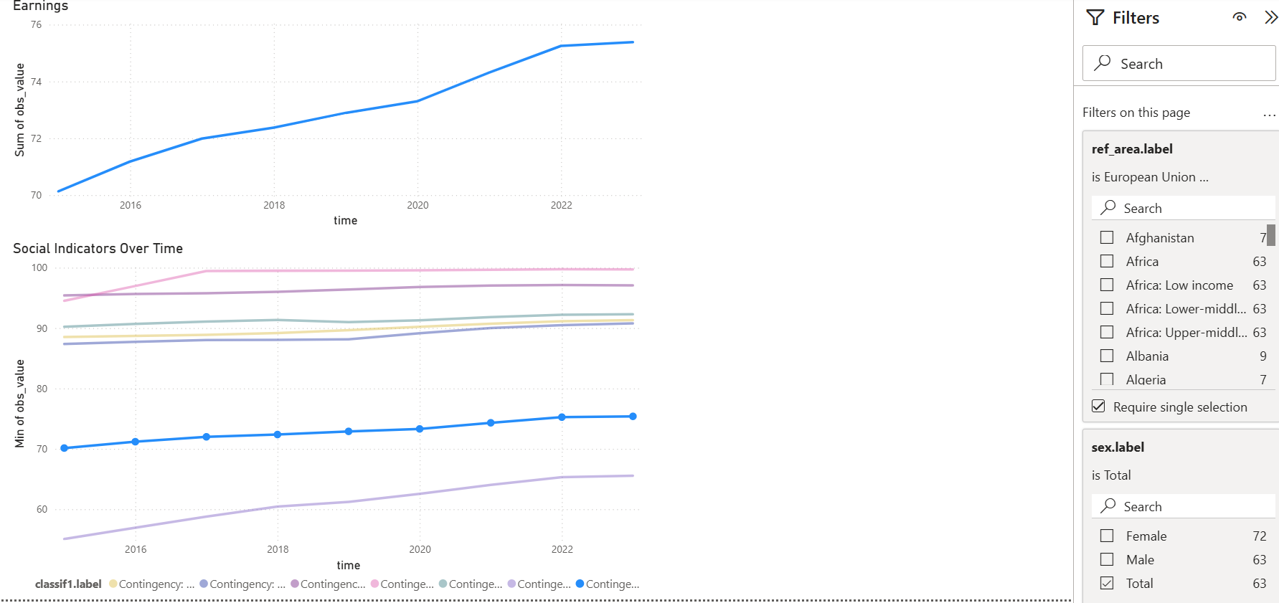

Earning & Skill level comparison:

Indicators to consider for the following study

SDG indicator 1.1.1 - Working poverty rate (percentage of employed living below US$2.15 PPP) (%)
SDG indicator 8.8.1 - Non-fatal occupational injuries per 100'000 workers
SDG indicator 8.8.1 - Fatal occupational injuries per 100'000 workers
SDG indicator 8.8.2 - Level of national compliance with labour rights (freedom of association and collective bargaining)

Data Used To Build The Indicators:
- First Indicator Data:
- 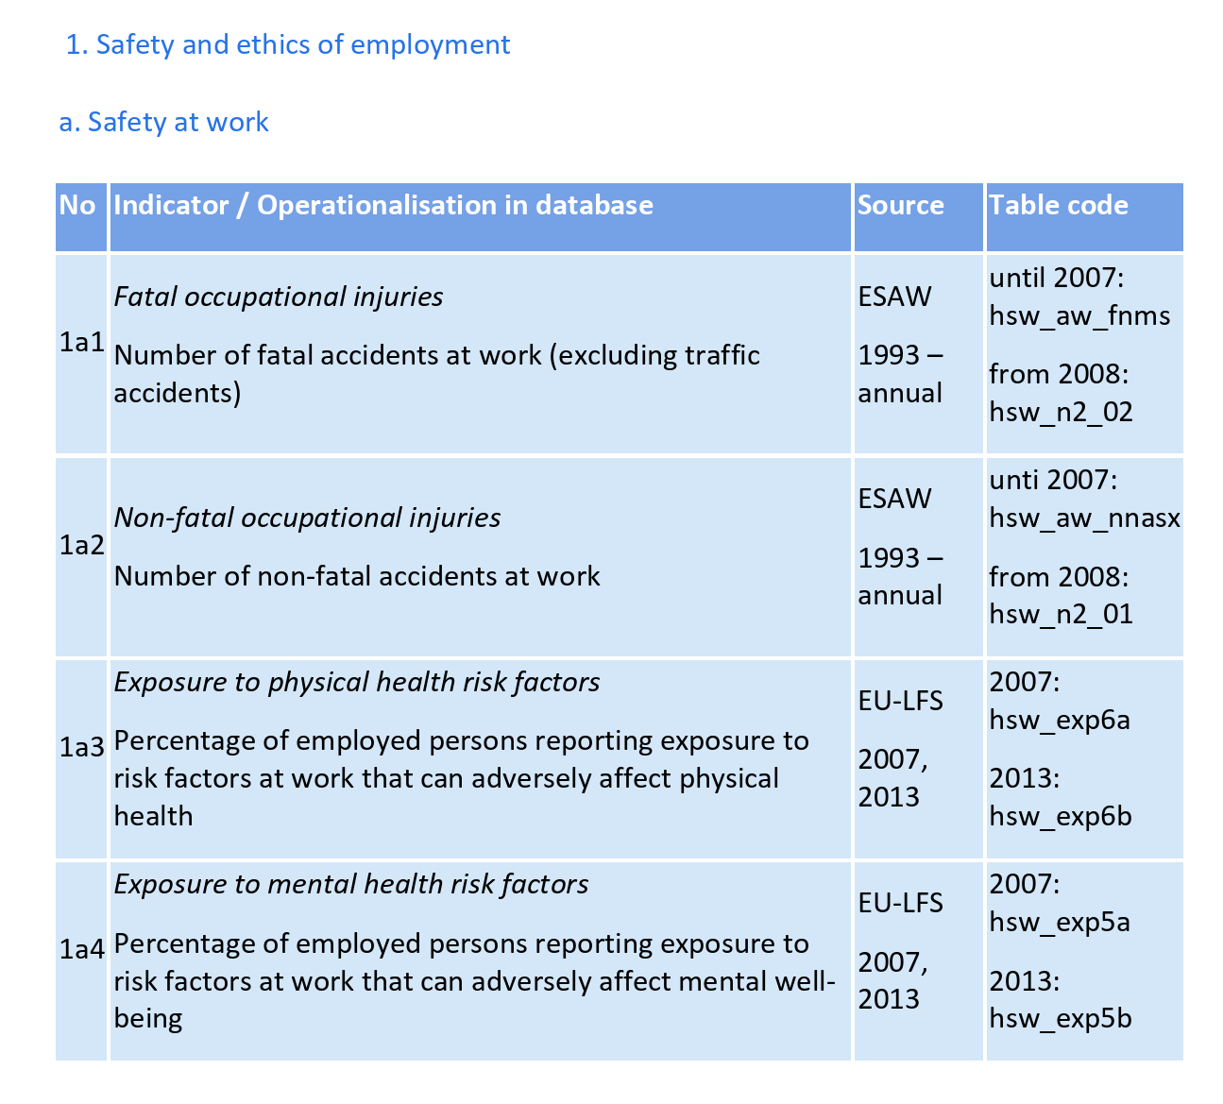
All the indicators and their respective data
- https://ec.europa.eu/eurostat/documents/341520/8195276/Quality+of+employment_UNECE+Framework.pdf/b8ff01d0-5c40-bb79-f9a2-d43a5d2ba1e6?t=1673274377303
All Related Dataset
- https://ec.europa.eu/eurostat/web/national-accounts/database
Potential Useful Datasets
- Employment by Data Industry
  - https://ec.europa.eu/eurostat/databrowser/view/nama_10_a10_e/default/table?lang=en&category=na10.nama10.nama_10_e_p
- Average Full Time Adjusted Salary Per Employee
  - https://ec.europa.eu/eurostat/databrowser/view/nama_10_fte/default/table?lang=en&category=na10.nama10.nama_10_e_p

